JOB VACANCY: Competitive Gymnastics and Gym for All Coach 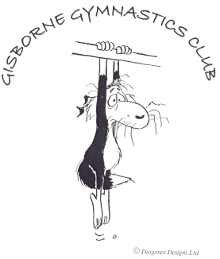
Location and lifestyle:
The Gisborne Gymnastics Club is located in sunny Gisborne (The first City to see the Sun rise each day). Gisborne has lots of amazing beaches that are safe to swim and fabulous to surf. Nothing is far in Gisborne and traffic jams are not on the daily experience list!
The housing market has a wide range from small to large houses, affordable to extravagant locations. There is something for every taste and price range.
Gisborne has 2 newly renovated theatres, which have regular productions and concerts all year round.
The Long Gisborne Summers & the great surf are definitely the attraction to why people come and stay here. Freedom camping, Rere rockslide, Doneraille Park, Eastwoodhill, Rail bike adventure, Wine tours and our big Rhythm and Vines festival are highlights of our region.

Our Club:
The Gisborne Gymnastics Club has got their own premises with a fully set up Gymnasium.
We have a wide range of established classes available, running all year round with a 3 week break during Christmas and New Year’s.
The GGC has a variety of class options for under 5-year olds, a strong Recreational Program 5-14-year olds, a tricking boys’ group 9+, several aerial silks groups from beginners to performers, competitive Gymnastics for boys and girls and a well-established holiday program.

The Position:
We would like to grow our club and are looking for an experienced, enthusiastic and passionate coach who is motivated to drive our programs further and beyond its current success.
The applicant should have a sound knowledge of basic to advanced gymnastic skills, should be able to assist with program planning, able to deliver a fun, engaging and yet technically correct and progressive program. Clear and positive communication skills are essential for this position.
This is a full-time position and remuneration will be according to qualification and experience.

Please send your application to:
Nicola Ludwig
Head Coach and Manager Gisborne Gymnastics Club
Email: gisgymoffice@gmail.com

